SOAP Member Community FAQs

What is the SOAP Community?
The SOAP Community is an online, members-only forum for collaboration and member dialogue. Through the group forums, SOAP invites members to share expertise, ask questions, and seek guidance from others. You can also find materials and rosters for committees, working groups and special interest groups that you are part of, as well as a searchable directory of obstetric anesthesia fellowship opportunities.
Where is the SOAP Community?
First, navigate to SOAP.org. Once you arrive, review Quick Links on the right navigation bar. Click on SOAP Community to view the usage guidelines and log in. You must be logged in as a SOAP member to access the community.
- Review the SOAP Community Guidelines
- Bookmark the direct link – Community.soap.org
What is my login for the SOAP Community?
Utilize your current SOAP.org membership username and password. If you forget your username and/or password, use the “retrieve username” or “reset password” links when you log into the SOAP.org website.
Do I need to read and agree to the SOAP Community Guidelines to participate?
Yes, please review the SOAP Community Guidelines to ensure you are aware of expectations regarding conduct in the SOAP Community. Once you have agreed, you will be redirected to the SOAP Community page.
How do I get started in the SOAP Community?
Three easy steps:
- Personalize – Once you have logged in to the SOAP Community, click on your name on the top right navigation area to update your profile and account settings.
  - Add photo: Click “view profile” and select the camera icon on the upper right side of the banner to add your profile photo. A square, head and shoulders, image is best.
  - Update subscriptions: Click “account settings” and use the “subscriptions” tab to update the frequency of communications from the community. We suggestion a daily digest and instant updates. This will also the fastest access to committee, working group and SIG posts.

- Take a tour – Go to the “dashboard” on the top navigation. Use the “get started” button on the upper left for a brief walk-through of the Community.

- Find your groups – Select “groups/SIGs” on the top navigation to see the group categories. Currently, the categories are special interest groups, steering committees, and working groups (subcommittees and tasks forces).
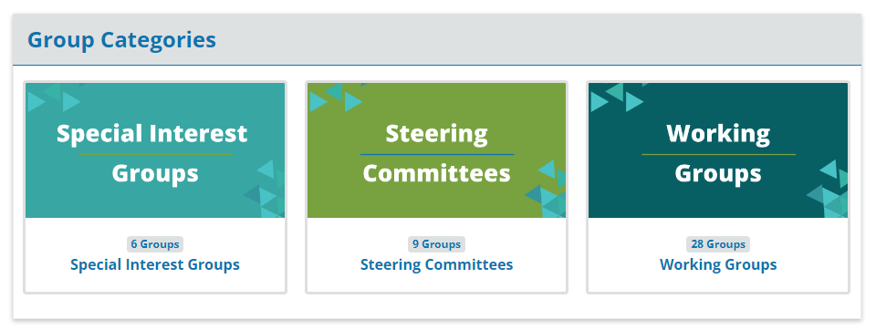
  - Special interest groups
    - Click on the special interest groups tile to see the list of SIGs.
    - In the bottom right corner of each SIG, you will see a “public” indicator. This means you can join a SIG immediately by clicking on the SIG of interest.
    - Click the SIG of interest. In the right corner of the SIG banner, click the “join” link to be added. SIGs are open to all members, and you may join as many as you like at no fee.
  - Steering committees and working groups (subcommittees and task forces)
    - Click on the steering committees or working groups tiles to see the list of committees, subcommittees and taskforces. Members of these groups are appointed by the committee chairs to specified terms.
    - In the bottom right corner of each committee and working group you will see a “private” indicator. This indicates these communities are accessible only to members of the groups.
    - Click to committee or working group of which you are a member to view, submit or respond to a post as well as access committee materials. Note that members are only visible in the roster after they have logged in to the community for the first time.
Once I join a group, what should I expect?
- Communication within the group should be posted in the SOAP Community. This can include meeting notes, questions, information about upcoming meetings, informational posts and more.
- Don’t forget, you have the option to choose how often, if at all, you want to receive notifications for each group of which you are a member.
  - Click on your name in the top right navigation of the SOAP Community home page, then select “account settings” and “subscriptions” to customize your preferences.

What should I post in a group?
Feel free to post information relative to the group or topic of interest, which may include information or materials to share, questions for the group, and details regarding an event or meeting. Watch for announcements, especially those with an event date or a response deadline.
Is there other content on in the SOAP Community that I should review?
- Dashboard is your “one stop shop” for all information related to the groups / committees to which you belong. Check this periodically for a quick glance to keep up to date. The newsfeed is like social media platforms, where you can engage with the content.
- Events will keep you up to date not only on association-wide events, but also on committee, SIG, webinar and townhall meetings.
- Fellowship Directory provides you an easy-to-navigate directory of programs that offer fellowships with a concentration in obstetric anesthesiology.
- Learning Center is a quick link to recordings and learning resources, as well as SOAP toolkits and consensus statements.
Why should I get involved in the SOAP Community?
- If you are part of a SOAP committee or working group, the SOAP Community provides you easy access to stay organized and up to date, connect with other members, and be involved.
- The SIG communities allow you to choose among groups where you have an interest, expertise, etc. and want to engage with other professionals in your field to share knowledge and gain insights.
Does the SOAP Community site offer a getting started tutorial?
Yes, it does. Click on “dashboard” in the top navigation and select “take Community tour” on the left navigation. The tour will give you a high-level orientation of the SOAP Community to get started.

If you have additional questions, please contact the SOAP staff at soap@soap.org.

