2021 Annual Meeting
FOR PRE-RECORED PRESENTATIONS
How to Start a local Recording in ZOOM

Zoom help article & video can be found here: https://support.zoom.us/hc/en-us/articles/201362473-Local-recording

Local recording is available to free and paid subscribers. Local recording allows participants to record meeting video and audio locally to a computer. The recorded files can be uploaded to a file storage service like Dropbox, Google Drive, or a streaming service like YouTube or Vimeo.
The host must record the meeting or grant the ability to record to a participant.
- Start a Zoom meeting as the host.
- Click the option to Record.
- If there is a menu, select Record on this Computer.
Hosts will see the following recording indicator in the top-left corner while recording is active.
Participants will see the following indicator in the top-left corner while the recording is active.
- Click Participants to see which participants are currently recording.
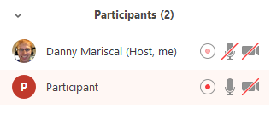
Note: Dial-in participants will hear a message informing them that the meeting is now being recorded unless disabled by the host.
- After the meeting has ended, Zoom will convert the recording so you can access the files.
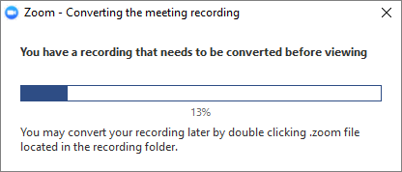
- Once the conversion process is complete, the folder containing the recording files will open.
Note: By default, the audio/video file (MP4) will be named Zoom_0.mp4. The audio only file (M4A) is named audio_only.m4a.
Note:
- If the meeting unexpectedly shuts down or if the conversion process is interrupted, the recording files could become corrupted and non-recoverable. Restarting or shutting down your computer, putting the hard disk to sleep, or closing your laptop will interrupt the conversion process.
- If the conversion process is not successful after the meeting has ended, you can try to convert the files again by navigating to the recording location and double clicking the recording files.
- You can record the meeting in different layouts including Active Speaker, Gallery View, and shared screen.

Stopping or pausing a local recording
During a Zoom recording, a participant can Stop or Pause the recording. If a participant stops the recording and starts it again, a new video file will be created for the next recording segment. If a participant pauses the recording and starts it again, Zoom will record to the same video file for the recording segment.
- After a recording has been started, click Pause or Stop Recording at the bottom.
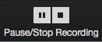
The recording can also be stopped or paused by clicking the indicator in the top left corner.
- When a recording is paused, the following indicator will be displayed in the meeting.
- To resume the recording, click Resume Recording at the bottom
The recording can also be resumed by clicking the indicator in the top left corner.
- After you stop the recording, you can access the local recording files on your computer.

